1

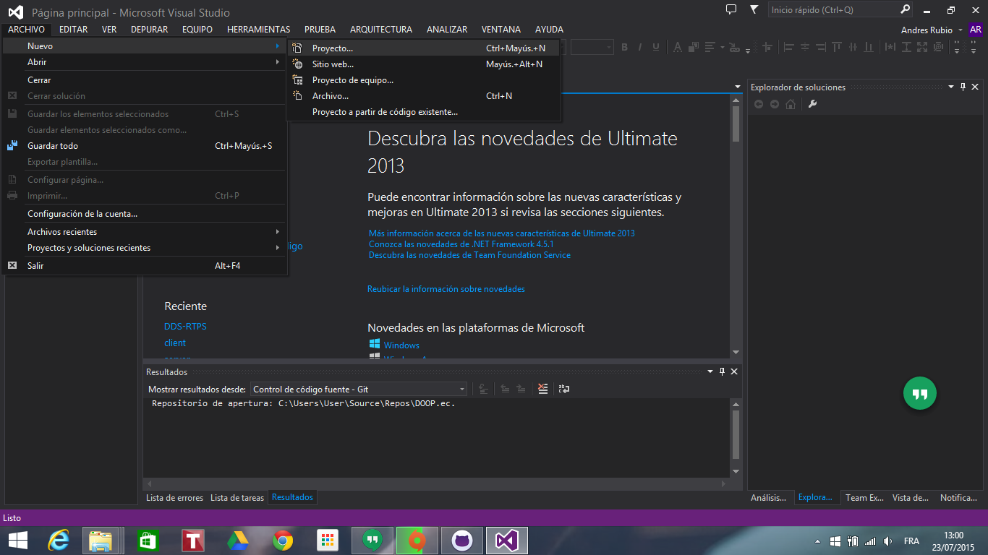

2

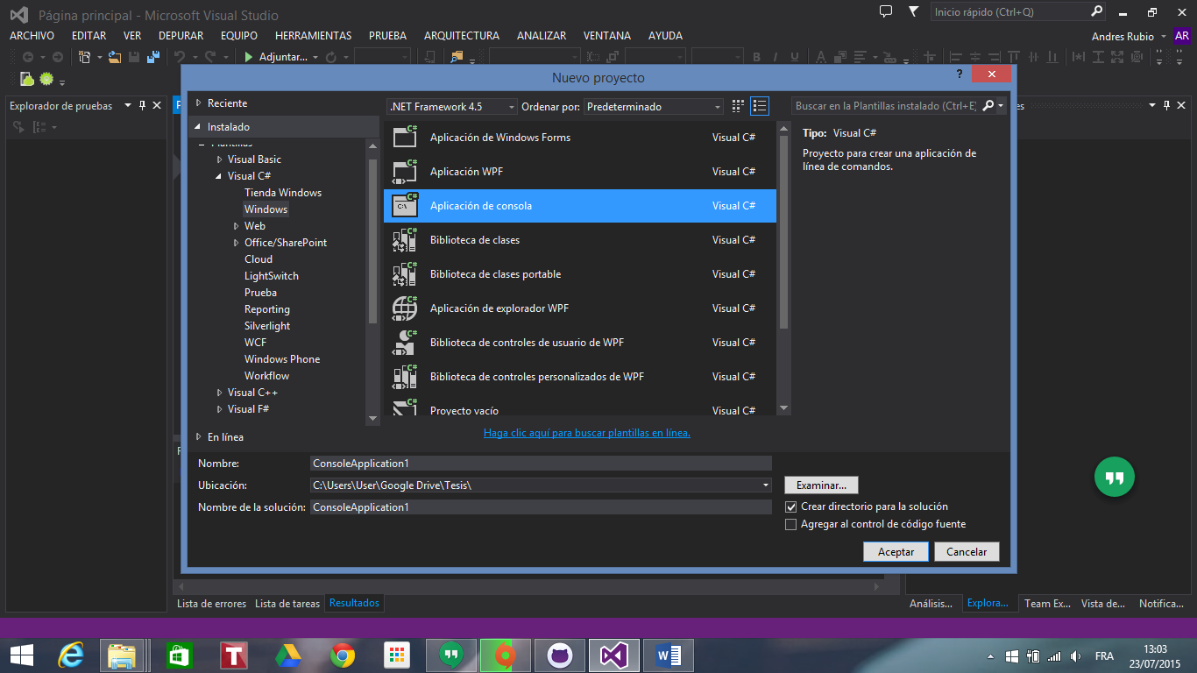

3

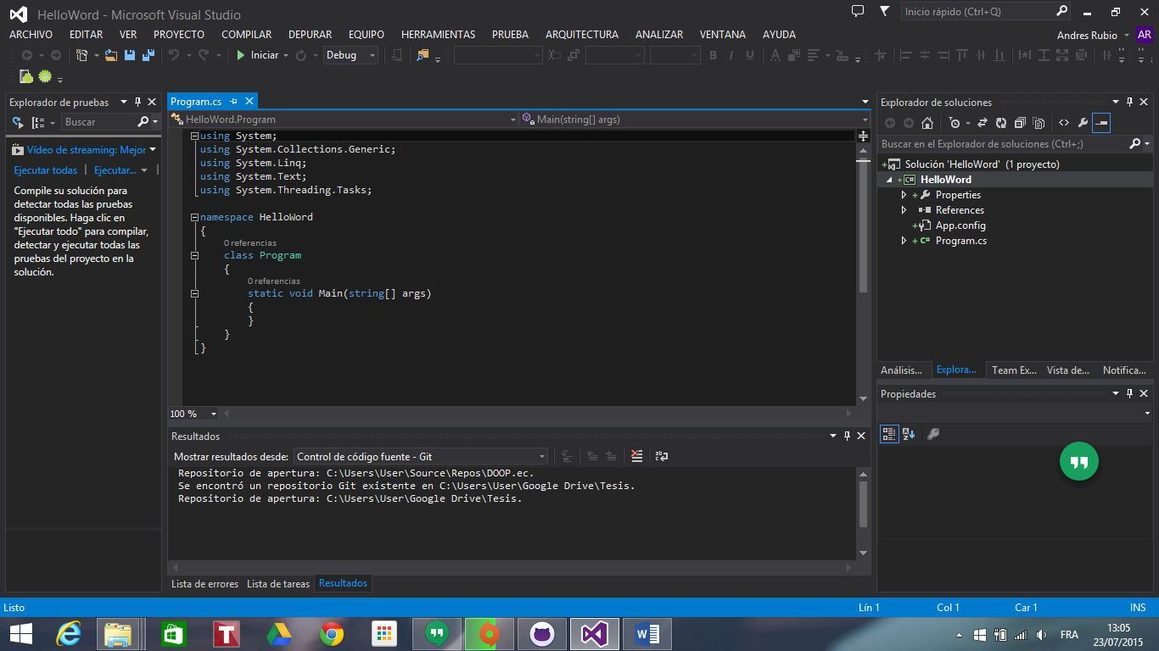

4

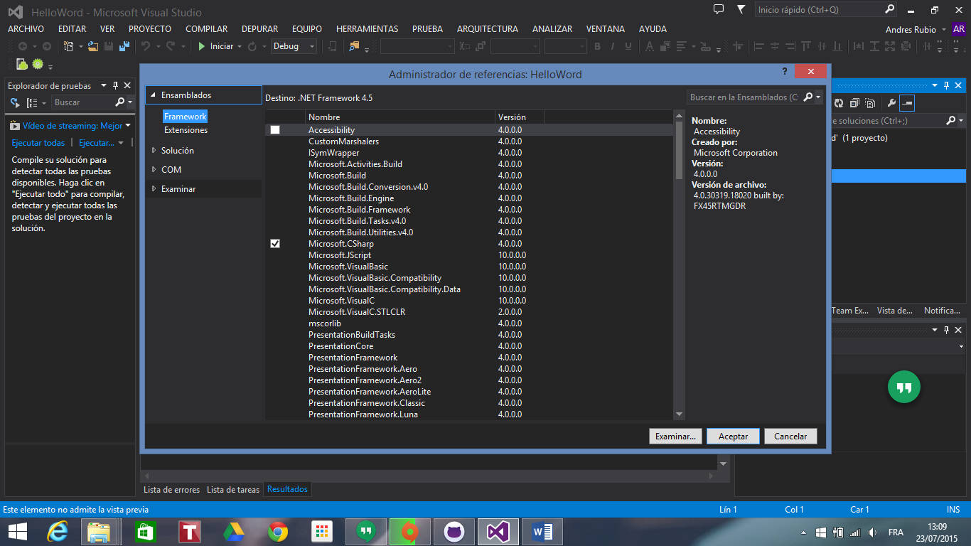

5

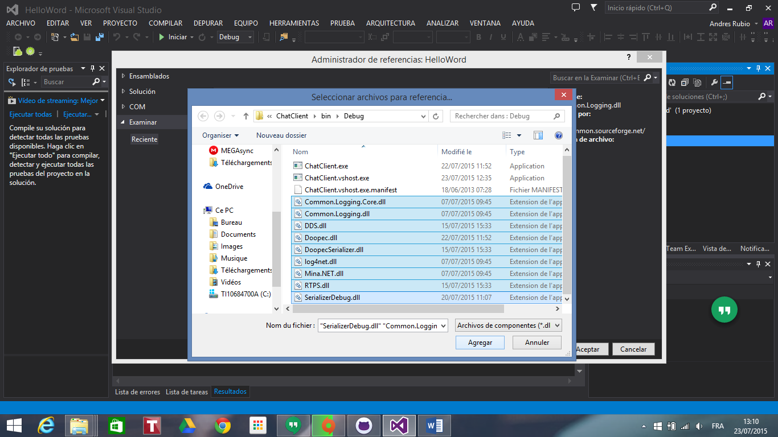

6



7

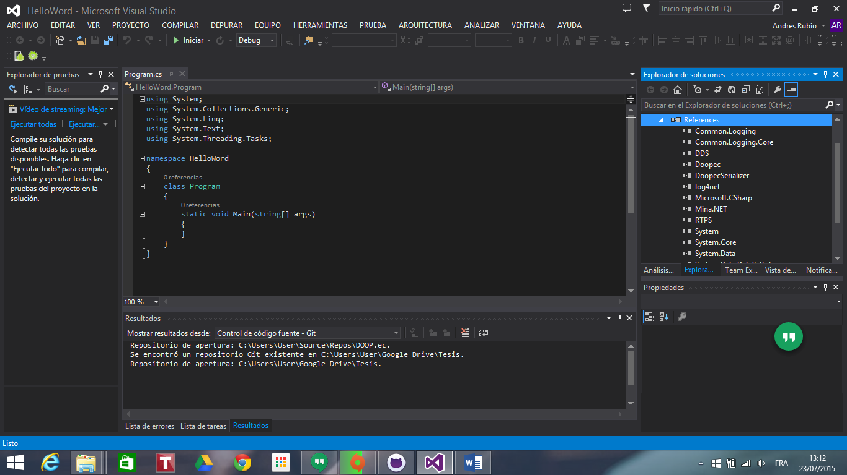

8

using DDS.ConversionUtils;

using Doopec.Rtps;

using ExampleDDS.Common;

using log4net;

using org.omg.dds.core;

using org.omg.dds.core.status;

using org.omg.dds.domain;

using org.omg.dds.pub;

using org.omg.dds.sub;

using org.omg.dds.topic;

